What is a class in Java
A class is a group of objects which have common properties.
A class in Java can contain:
- Fields
- Methods
- Constructors
- Blocks
- Nested class and interface
Example:
- class <class name>{
- field.
- method.
- }

Object: Run time or Real Time representation of a class

Method in Java
It is a block of code (or) collection of statements.

Advantage of Method
- Code Reusability
- Code Optimization
INHERITANCE:
Inheritance in Java is a mechanism in which one object acquires all the properties and behaviours of a parent object.
It is an important part of OOPs (Object Oriented programming system).

Inheritance represents the IS-A relationship which is also known as a parent-child relationship.
Example:

// Superclass

class Vehicle {

void move() {

System.out.println("Vehicle is moving");

}

}

// Subclass

class Car extends Vehicle {

void horn() {

System.out.println("Car horn sounds");

}

}

// Main class

public class Main {

public static void main(String[] args) {

Car c = new Car();

c.move(); // inherited from Vehicle

c.horn(); // defined in Car

}

}

🔹 Output:

csharp

Copy

Edit

Vehicle is moving

Car horn sounds

Types of inheritance in java
On the basis of class, there can be three types of inheritance in java: single, multilevel and hierarchical.
In java programming, multiple and hybrid inheritance is supported through interface only. We will learn about interfaces later.
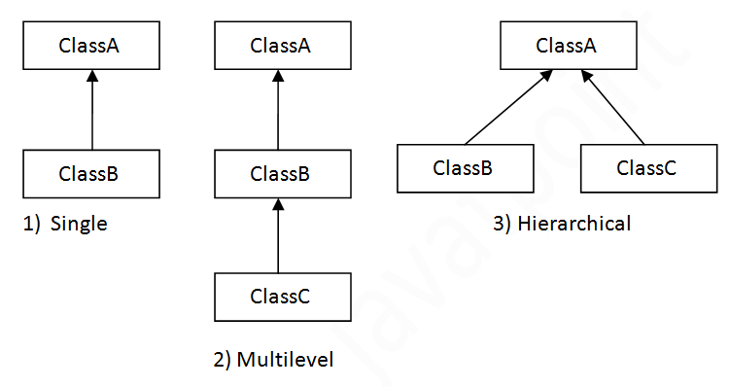

Single Inheritance Example
When a class inherits another class, it is known as a single inheritance. In the example given below, Dog class inherits the Animal class, so there is the single inheritance.
File: TestInheritance.java
- class Animal{
- void eat(){
- System.out.println("eating...");}
- }
- class Dog extends Animal{
- void bark(){
- System.out.println("barking...");}
- }
- class TestInheritance{
- public static void main(String args[]){
- Dog d=new Dog();
- d.bark();
- d.eat();
- }}

Multilevel Inheritance Example
When there is a chain of inheritance, it is known as multilevel inheritance. As you can see in the example given below, BabyDog class inherits the Dog class which again inherits the Animal class, so there is a multilevel inheritance.
File: TestInheritance2.java
- class Animal{
- void eat(){System.out.println("eating...");}
- }
- class Dog extends Animal{
- void bark(){System.out.println("barking...");}
- }
- class BabyDog extends Dog{
- void weep(){System.out.println("weeping...");}
- }
- class TestInheritance2{
- public static void main(String args[]){
- BabyDog d=new BabyDog();
- d.weep();
- d.bark();
- d.eat();
- }}
POLYMORPHISM:
Polymorphism in Java is a concept by which we can perform a single action in different ways.
Polymorphism is derived from 2 Greek words: poly and morphs. The word "poly" means many and "morphs" means forms. So polymorphism means many forms.

Runtime polymorphism or Dynamic Method Dispatch is a process in which a call to an overridden method is resolved at runtime rather than compile-time.
Example:
- class Bike{
- void run(){System.out.println("running");}
- }
- class Splendor extends Bike{
- void run(){System.out.println("running safely with 60km");}

- public static void main(String args[]){
- Bike b = new Splendor();//upcasting
- b.run();
- }
- }
- Output:
- running safely with 60km.

class Animal{
void eat(){
System.out.println("animal is eating...");}
}

class Dog extends Animal{
void eat(){
System.out.println("dog is eating...");}

public static void main(String args[]){

Animal a = new Dog();
a.eat();
}
}
✅ Types of Polymorphism in Java:
Type | Description | Example Type
Compile-time Polymorphism | Method overloading (resolved at compile time) | Static
Runtime Polymorphism | Method overriding (resolved at runtime) | Dynamic

METHOD OVERLOADING:
If a class has multiple methods having same name but different in parameters, it is known as Method Overloading.

class Adder{
static int add(int a,int b){
return a+b;}
static int add(int a,int b,int c){
return a+b+c;}
}
class TestOverloading1{
public static void main(String[] args){
System.out.println(Adder.add(11,11));
System.out.println(Adder.add(11,11,11));
}}

Method Overrding:
If subclass (child class) has the same method as declared in the parent class, it is known as method overriding in Java.
Same method name but different classes
class Animal {
void sound() {
System.out.println("Animal makes a sound");
}
}

class Dog extends Animal {
void sound() {
System.out.println("Dog barks");
}
}

public class Main {
public static void main(String[] args) {
Animal myAnimal = new Dog(); // Upcasting
myAnimal.sound(); // Calls Dog's sound() method at runtime
}
}

EXCEPTION:
Exception Handling is a mechanism to handle runtime errors such as ClassNotFoundException, IOException, SQLException, RemoteException, etc.
public class JavaExceptionExample{
public static void main(String args[]){
try{
//code that may raise exception
int data=100/0;
}catch(ArithmeticException e){System.out.println(e);}
//rest code of the program
System.out.println("rest of the code...");
}
}

Abstraction:
Abstraction is a process of hiding the implementation details and showing only functionality to the user.
1. Abstract Class
An abstract class cannot be instantiated. It can have both abstract methods (without body) and concrete methods (with implementation).
🔸 Example:
abstract class Animal {
abstract void makeSound(); // abstract method

void eat() {
System.out.println("This animal eats food.");
}
}

class Dog extends Animal {
void makeSound() {
System.out.println("Dog barks");
}
}

public class Main {
public static void main(String[] args) {
Animal myDog = new Dog();
myDog.makeSound(); // "Dog barks"
myDog.eat(); // "This animal eats food."
}
}

🧩 2. Interface
An interface is a completely abstract class that defines a set of methods that a class must implement.
interface Vehicle {
void start();
}

class Car implements Vehicle {
public void start() {
System.out.println("Car started");
}
}

public class Main {
public static void main(String[] args) {
Vehicle myCar = new Car();
myCar.start(); // "Car started"
}
}

Constructors in Java

Special type of method used to initiate an instance variable
There are two rules defined for the constructor.
- Constructor name must be the same as its class name
- A Constructor must have no explicit return type
- A Java constructor cannot be abstract, static, final, and synchronized

Types of Java constructors
There are two types of constructors in Java:
- Default constructor (no-arg constructor)
- //Java Program to create and call a default constructor
- class Bike1{
- //creating a default constructor
- Bike1(){System.out.println("Bike is created");}
- //main method
- public static void main(String args[]){
- //calling a default constructor
- Bike1 b=new Bike1();
- }
- }

Parameterized constructor

- class Student4{
- int id;
- String name;
- //creating a parameterized constructor
- Student4(int i,String n){
- id = i;
- name = n;
- }
- //method to display the values
- void display(){System.out.println(id+" "+name);}

- public static void main(String args[]){
- //creating objects and passing values
- Student4 s1 = new Student4(111,"Karan");
- Student4 s2 = new Student4(222,"Aryan");
- //calling method to display the values of object
- s1.display();
- s2.display();
- }
- }

Static Variables (Class Variables)
- Declaration:
  - Static variables are declared using the static keyword within a class but outside any method, constructor, or block.
- Memory Allocation:
  - Only one copy of a static variable is created, regardless of how many instances of the class are created. This single copy is shared among all instances.
- Access:
  - Static variables can be accessed directly by the class name, without needing an instance of the class.
  - Example: ClassName.staticVariable
- Lifetime:
  - Static variables are initialized when the class is loaded and remain in memory until the class is unloaded.
- Scope:
  - They are accessible in all static and non-static methods of the class.
- Example:
public class MyClass {
static int staticVar = 10;
public static void main(String[] args) {
System.out.println(MyClass.staticVar); // Accessing directly using the class name
}
}

Dynamic Variables (Instance Variables)
- Declaration:
  - Instance variables are declared within a class but outside any method, constructor, or block, without the static keyword.
- Memory Allocation:
  - A new copy of an instance variable is created for each instance of the class.
- Access:
  - Instance variables can be accessed using the reference variable of the class.
  - Example: objectReference.instanceVariable
- Lifetime:
  - Instance variables are created when an object is instantiated and destroyed when the object is destroyed.
- Scope:
  - They are accessible in all instance methods, constructors, and blocks in the class.
- Example:

public class MyClass {
int instanceVar = 20;
public static void main(String[] args) {
MyClass obj1 = new MyClass();
MyClass obj2 = new MyClass();
System.out.println(obj1.instanceVar); // Accessing using object reference
System.out.println(obj2.instanceVar);
}
}
Summary of Differences
Feature | Static Variable | Dynamic (Instance) Variable
Keyword | static | No static keyword
Memory Allocation | Once per class, shared among all instances | Once per instance
Access | Class name or instance reference | Instance reference only
Lifetime | As long as the class is loaded | As long as the instance exists
Initialization | When the class is loaded | When an instance is created
Scope | Accessible in static and instance methods | Accessible in instance methods, constructors, and blocks

Abstract and Interface:
Abstract class can have both abstract and non-abstract methods, but interface has only abstract methods
interface-implements keyword, Abstract-extends keyword
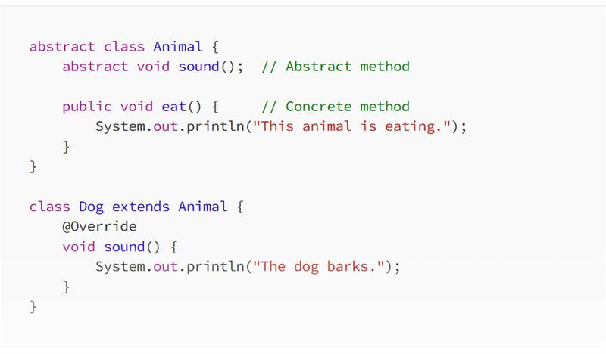
Global & Local variables:
inside the method local variables
inside the class outside method global variables

public class VariableScopeExample {
// Global variable (instance variable)
int globalVar = 10;
public void myMethod() {
// Local variable
int localVar = 20;
System.out.println("Local variable: " + localVar); // Output: 20
System.out.println("Global variable: " + globalVar); // Output: 10
}
While Loop
A while loop checks the condition before executing the loop body. If the condition is false initially, the loop body may never execute. This makes the while loop an entry-controlled loop.
Example in C++:
#include <iostream>
using namespace std;

int main() {
int count = 5;
while (count < 5) {
count += 1;
}
cout << "Final value of count = " << count << endl;
return 0;
}
Output:
Final value of count = 5
In this example, the loop body does not execute because the condition count < 5 is false initially.
Do-While Loop
A do-while loop executes the loop body at least once before checking the condition. This makes the do-while loop an exit-controlled loop.
Example in C++:
#include <iostream>
using namespace std;

int main() {
int count = 5;
do {
count += 1;
} while (count < 5);
cout << "Final value of count = " << count << endl;
return 0;
}
Output:
Final value of count = 6

Constructor
- Same Name as the Class: A constructor has the same name as the class in which it is defined.
- No Return Type: Constructors do not have any return type, not even void. The main purpose of a constructor is to initialize the object, not to return a value.
- Automatically Called on Object Creation: When an object of a class is created, the constructor is called automatically to initialize the object’s attributes.
class Geeks {
// Constructor
Geeks()
{
super();
System.out.println("Constructor Called");
}

// main function
public static void main(String[] args)
{
Geeks geek = new Geeks();
}
}

List<WebElement> elementName = driver.findElements(By.LocatorStrategy("LocatorValue"));

final variable means the value cannot be changed once initialized
Final method means the method cannot be overriden

Finally is used in try catch blocks to handle exceptions where these lines of code are executed even though there occurs an exception

interface in Java
it is a collection of abstract methods and constants(static and final fields)
An interface in Java is a blueprint of a class. It has static constants and abstract methods.

- //Interface declaration: by first user
- interface Drawable{
- void draw();
- }
- //Implementation: by second user
- class Rectangle implements Drawable{
- public void draw(){
- System.out.println("drawing rectangle");}
- }
- class Circle implements Drawable{
- public void draw(){
- System.out.println("drawing circle");}
- }
- //Using interface: by third user
- class TestInterface1{
- public static void main(String args[]){
- Drawable d=new Circle();//In real scenario, object is provided by method e.g. getDrawable()
- d.draw();
- }}
What is Encapsulation in Java?
Encapsulation is one of the core principles of Object-Oriented Programming (OOP) in Java. It is the technique of wrapping data (variables) and code (methods) together as a single unit — typically inside a class — and restricting direct access to some of the object's components.

🔹 Definition:
Encapsulation is the process of hiding internal details of an object and only exposing what is necessary through public methods (getters/setters).

✅ Key Concepts of Encapsulation:
- Declare class variables as private
- Provide public getter and setter methods to access and update their values

🧩 Example:
java
CopyEdit
class Person {
// Step 1: Private fields
private String name;
private int age;

// Step 2: Public getters and setters
public String getName() {
return name;
}

public void setName(String newName) {
name = newName;
}

public int getAge() {
return age;
}

public void setAge(int newAge) {
if (newAge > 0) {
age = newAge;
}
}
}
🔸 Using the class:
java
CopyEdit
public class Main {
public static void main(String[] args) {
Person p = new Person();
p.setName("Alice");
p.setAge(25);

System.out.println(p.getName()); // Output: Alice
System.out.println(p.getAge()); // Output: 25
}
}

BDD Framework questions
what is BDD framework why do we use BDD
- BDD is Behavior-driven development. It is one of the techniques of agile software development.
It offers a way to write tests that anybody can understand, regardless of their technical knowledge.
In BDD, users (business analysts, product owners) first write scenarios or acceptance tests that describe the behavior of the system from the customer’s perspective, for review and sign-off by the product owners before developers write their codes. Cucumber framework uses Ruby programming language.

What is Diff b/w cucumber and selenium

Cucumber vs Selenium
In this section, we will study the difference between Cucumber, Selenium and UFT.
Cucumber | Selenium
Cucumber software is free | It is free
Cucumber software is a behavior driven development tool | It’s a Functional and Performance ( Selenium Grid) test tool
Plugin in Cucumber testing tool works faster | Plugins are slower than cucumber
Cucumber Framework supports other language as well beyond Ruby like Java, Scala, Groovy etc. | Selenium supports Java, .Net and many other languages
Writing automation steps are joint effort of testers and developer | Like Cucumber Tool, writing automation steps are joint effort of testers and developer
Cucumber testing tool supports only web environment |  | Supports only web environment

✅ What is a Feature File? (Simplified Explanation)
A Feature File is a simple text file used in testing (especially with tools like Cucumber) to describe how a system should behave — in plain English. It helps developers, testers, and even non-technical people understand what a test is doing.
This plain-English style is called Gherkin language.

🔹 Main Keywords in a Feature File:
Keyword | Meaning (Simple Explanation)
Feature | Describes what is being tested (e.g., Login, Search).
Scenario | Describes one specific test case or example.
Scenario Outline | Runs the same scenario with different data using a table.
Given | Describes the starting point or setup before the test (e.g., "Given the user is logged in").
When | Describes the action taken by the user (e.g., "When the user clicks on Login").
Then | Describes the expected result (e.g., "Then the dashboard is displayed").
Background | Defines common steps that should run before every scenario in that file.

What is “Step Definition”?
Step definition maps the Test Case Steps in the feature files(introduced by Given/When/Then) to code.

Why use Cucumber with Selenium?
Cucumber and Selenium are two popular technologies. Many organizations use Selenium for functional testing. These organizations which are using Selenium want to integrate Cucumber with Selenium as Cucumber helps you to read and to understand the application flow.

What is Selenium?
Selenium is an automation tool which is a widely used tool for Functional Testing of the web-based application. Selenium supports different language like ruby, java, python C#, etc.

Types of Waits in Selenium:
- Implicit Wait: Waits for a specified time for all elements to appear.

driver.manage().timeouts().implicitlyWait(10, TimeUnit.SECONDS);
- Explicit Wait: Waits for a specific condition to be met for a particular element.

WebDriverWait wait = new WebDriverWait(driver, 10);
WebElement element = wait.until(ExpectedConditions.visibilityOfElementLocated(By.id("elementId")));
- Fluent Wait: Waits with custom polling intervals and can ignore specific exceptions.

Wait<WebDriver> wait = new FluentWait<>(driver)
.withTimeout(Duration.ofSeconds(30))
.pollingEvery(Duration.ofSeconds(5))
.ignoring(NoSuchElementException.class);

WebElement element = wait.until(driver -> driver.findElement(By.id("elementId")));

Types of Assertions in Testing:
- Hard Assertions: Fail the test immediately when an assertion fails.
  - Example: assertEquals(expected, actual);
- Soft Assertions: Collect all failures and report them at the end of the test.
  - Exam
SoftAssert softAssert = new SoftAssert();
softAssert.assertEquals(expected, actual);
softAssert.assertAll();
- Conditional Assertions: Assert conditions based on specific logic.
  - Example:
java
Copy code
if (condition) {
assertTrue(condition);
}
- Assert Types in Selenium:
  - assertTrue() / assertFalse(): Check if a condition is true or false.
  - assertEquals() / assertNotEquals(): Check if two values are equal or not.
  - assertNull() / assertNotNull(): Check if an object is null or not.
How to Handle Dynamic Web Elements?
- Explicit Waits. Explicit waits are the most common way to handle delayed loading elements. ...
- Fluent Waits. ...
- CSS Selectors and XPath. ...
- Handling Elements Inside Frames. ...
- Using Relative Element Positions. ...
- Multiple Attributes. ...
- Refresh the Page. ...
- Retrying Mechanism.

The Bug Life Cycle (or Defect Life Cycle) is the sequence of stages a bug goes through during its life in a software development process. It begins when a bug is identified and ends when it is closed after being resolved or deemed invalid. The process ensures effective bug tracking and resolution.
Common Stages in the Bug Life Cycle:
- New
  - The bug is identified and reported but has not yet been reviewed or assigned.
- Assigned
  - The bug is assigned to a developer or a team for further investigation.
- Open
  - The developer acknowledges the bug and starts analyzing and fixing it.
- In Progress / Work in Progress
  - The bug is actively being worked on by the developer.
- Fixed
  - The developer resolves the issue and marks it as fixed. The fix is ready for testing.
- Pending Retest / Ready for Retest
  - The fixed bug is sent back to the testing team to verify if the fix works.
- Retesting
  - The testing team verifies whether the bug has been successfully fixed in the application.
- Verified
  - If the bug is no longer reproducible and behaves as expected, it is marked as verified.
- Closed
  - After verification, the bug is marked as closed if it meets the quality standards.
Other Possible States:
- Reopened
  - If the bug is still reproducible after being fixed, it is reopened and sent back to the developer.
- Deferred / Postponed
  - The bug is considered low priority and scheduled for fixing in a future release.
- Rejected / Not a Bug
  - The bug report is invalid, caused by a misunderstanding, or is not a genuine issue.
- Duplicate
  - The reported bug is found to be a duplicate of an existing issue.
Importance of the Bug Life Cycle:
- Ensures accountability for bug resolution.
- Improves communication between testers, developers, and other stakeholders.
- Helps track and prioritize bugs efficiently.
- Contributes to delivering high-quality software.

What is SDLC? (In Simple Words)
SDLC stands for Software Development Life Cycle.
It is the step-by-step process used to build software.

🔹 Simple Definition:
SDLC is a step-by-step process or a standard procedure to develop any new software is called a SDLC

🔸 Main Steps in SDLC (Easy to Understand):
- Requirement Gathering
👉 Understand what the customer or user wants.
- Planning
👉 Decide how to do the work — what tools, time, and people are needed.
- Design
👉 Create the structure of the software (like a blueprint).
- Development
👉 Developers write the code to build the software.
- Testing
👉 Test the software to make sure it works correctly and has no bugs.
- Deployment
👉 Release the software so users can start using it.
- Maintenance
👉 Fix issues and make improvements after the software is released.

What is STLC? (In Simple Words)
STLC stands for Software Testing Life Cycle.
It is the step-by-step process followed to test software and make sure it works correctly.

🔹 Simple Definition:
STLC is step-by-step process or a standard procedure to Test any new software is called a STLC

🔸 Main Steps in STLC (Easy to Understand):
- Requirement Analysis
👉 Understand what needs to be tested.
- Test Planning
👉 Decide how testing will be done, what tools to use, and who will do it.
- Test Case Design
👉 Write detailed test steps (test cases) to check the software.
- Test Environment Setup
👉 Prepare the system where tests will run (like setting up servers or browsers).
- Test Execution
👉 Run the test cases and check if the software behaves as expected.
- Defect Reporting
👉 If something doesn’t work, report bugs to developers.
- Test Closure
👉 Final step: testing is complete, results are shared, and lessons are noted for future projects.

Diff b/w driver.navigate() and driver.get()
driver.navigate() will not have inbuilt synchronization to wait and does not wait till all the webelements in the page are loaded
driver.get() will have inbuilt synchronization to wait and waits till all the webelements in the page are loaded

getWindowhandles();
Set<String> windows=driver.getWindowhandles();
Iterator it=windows.iterator();
String parentwindow=it.next();---this gives parent window
String childwindow=it.next();---this gives child window
driver.switchto.window(parentwindow);

Diff b/w Assert & Verify:
An "assert" will halt the test execution if a condition is not met, immediately marking the test as failed.
A "verify", on the other hand, will continue executing the test even if a condition fails, typically reporting the failure at the end of the test.

implicitlyWait:
driver.manage().timeouts().implicitlyWait(10, TimeUnit.SECONDS);
wait time is declared globally for a webpage

Explicit wait: waits for a particular element to load on webpage
WebDriverWait wait = new WebDriverWait(driver,30);
wait.until(ExpectedConditions.visibilityOfElementLocated(By.xpath("//div[contains(text(),)

Thread.sleep :
will halt the execution of program for the defined time period
Implicit wait will not halt the execution of program. If the element is found within time period it will proceed with next step

- NoSuchElementException: This exception occurs when an element cannot be found on the web page. try { driver.findElement(By.id("submit")).click(); } catch (NoSuchElementException e) { System.out.println("Element not found"); }
- NoSuchWindowException: This exception is thrown when trying to switch to a window that does not exist. try { driver.switchTo().window("windowName"); } catch (NoSuchWindowException e) { System.out.println("Window not found"); }
- NoSuchFrameException: This exception occurs when trying to switch to a frame that does not exist. try { driver.switchTo().frame("frameName"); } catch (NoSuchFrameException e) { System.out.println("Frame not found"); }
- NoAlertPresentException: This exception is thrown when trying to switch to an alert that is not present. try { driver.switchTo().alert().accept(); } catch (NoAlertPresentException e) { System.out.println("Alert not present"); }
- ElementNotVisibleException: This exception occurs when an element is present in the DOM but is not visible. try { driver.findElement(By.id("submit")).click(); } catch (ElementNotVisibleException e) { System.out.println("Element not visible"); }
- ElementNotSelectableException: This exception is thrown when an element is present but cannot be selected. try { Select dropdown = new Select(driver.findElement(By.id("dropdown"))); } catch (ElementNotSelectableException e) { System.out.println("Element not selectable"); }
- TimeoutException: This exception occurs when a command takes longer than the specified wait time to complete. try { WebDriverWait wait = new WebDriverWait(driver, 10); wait.until(ExpectedConditions.visibilityOfElementLocated(By.id("submit"))); } catch (TimeoutException e) { System.out.println("Timeout waiting for element"); }
- StaleElementReferenceException: This exception is thrown when an element is no longer present in the DOM. try { WebElement element = driver.findElement(By.id("element")); element.click(); } catch (StaleElementReferenceException e) { System.out.println("Element is stale"); }
Basic Selenium Java Interview Questions
- What is Selenium?
  - Selenium is an open-source tool used for automating web browsers. It supports multiple languages including Java, Python, and C#.
- What are the components of Selenium?
  - Selenium IDE
  - Selenium WebDriver
  - Selenium Grid
  - Selenium RC (deprecated).
- What is Selenium WebDriver?
  - It’s a tool used to automate web application testing. It interacts directly with the browser using native compatibility
• How do you locate elements in Selenium?
  - Using locators like:
  - ID
  - Name
  - Class Name
  - Tag Name
  - Link Text / Partial Link Text
  - CSS Selector
  - XPath.
  - What is XPath and its types?
  - XPath is a language used to locate elements in XML documents. Types:
  - Absolute XPath
  - Relative XPath.

• What is the difference between findElement() and findElements()?
  - findElement() returns a single WebElement.
  - findElements() returns a list of WebElements.
- What are Assertions in Selenium?
  - Assertions are used to validate test results. Types include:
  - Hard Assert
  - Soft Assert (via TestNG).
- How do you handle dropdowns in Selenium?
  - Using the Select class in Java:
Select dropdown = new Select(driver.findElement(By.id("dropdownId"))); dropdown.selectByVisibleText("Option");

• How do you handle alerts and pop-ups?
  - Using Alert interface:
Alert alert = driver.switchTo().alert();
alert.accept();
- What are waits in Selenium?
  - Types:
  - Implicit Wait
  - Explicit Wait
  - Fluent Wait
- How do you run tests in multiple browsers?
- By setting up WebDriver for each browser (ChromeDriver, FirefoxDriver, etc.) and using Selenium Grid for parallel execution.

• How do you handle multiple windows in Selenium?
  - Use getWindowHandles() and switchTo().window() to switch between windows.
- 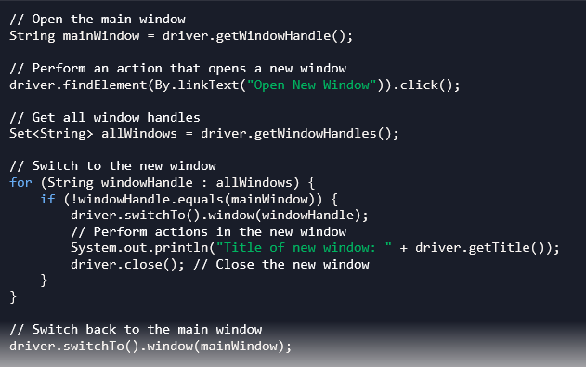

- How do you handle frames in Selenium?
  - Use switchTo().frame() by index, name, or WebElement.
1, Index
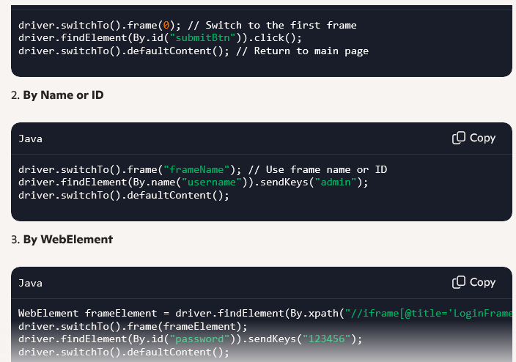
- What is Page Object Model (POM)?
  - A design pattern that enhances test maintenance and reduces code duplication by creating object repositories for web elements.
- What is the difference between driver.close() and driver.quit()?
  - close() closes the current browser window.
  - quit() closes all browser windows and ends the WebDriver session.

